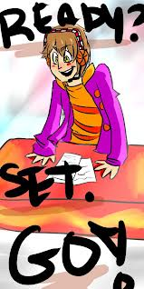

EVERY NIGHT-
READY, SET, GO SHORT LIST

READY
R- Read AGENDA
E- Edit your "to do" list (Agenda list) as you go
A- Ask your parents to read/sign important
papers/flyers
D- Do your homework, study and other tasks on
agenda
Y- You are AWESOME!

SET
S- See if parents are done signing paperwork
E- EDIT your AGENDA. Check off each
completed task.
T- Time to organize your Binder!

GO!!!!
- AHHHHHHH, now you can relax and rest knowing you did your best!
- TEXT or EMAIL AN AVID BUDDY- "I’m ready to GO!!!"
- Go get those "A"s

